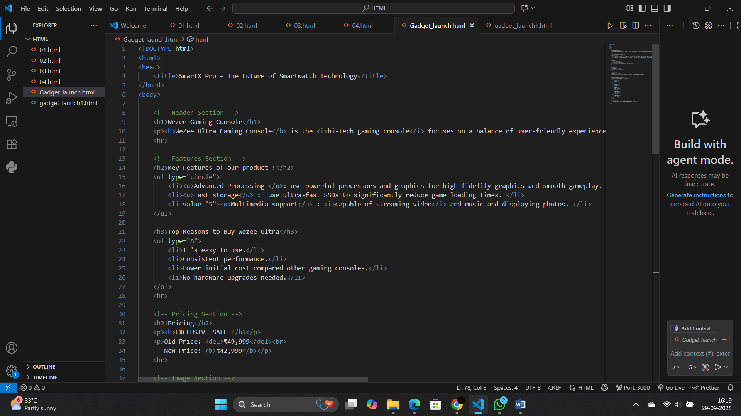

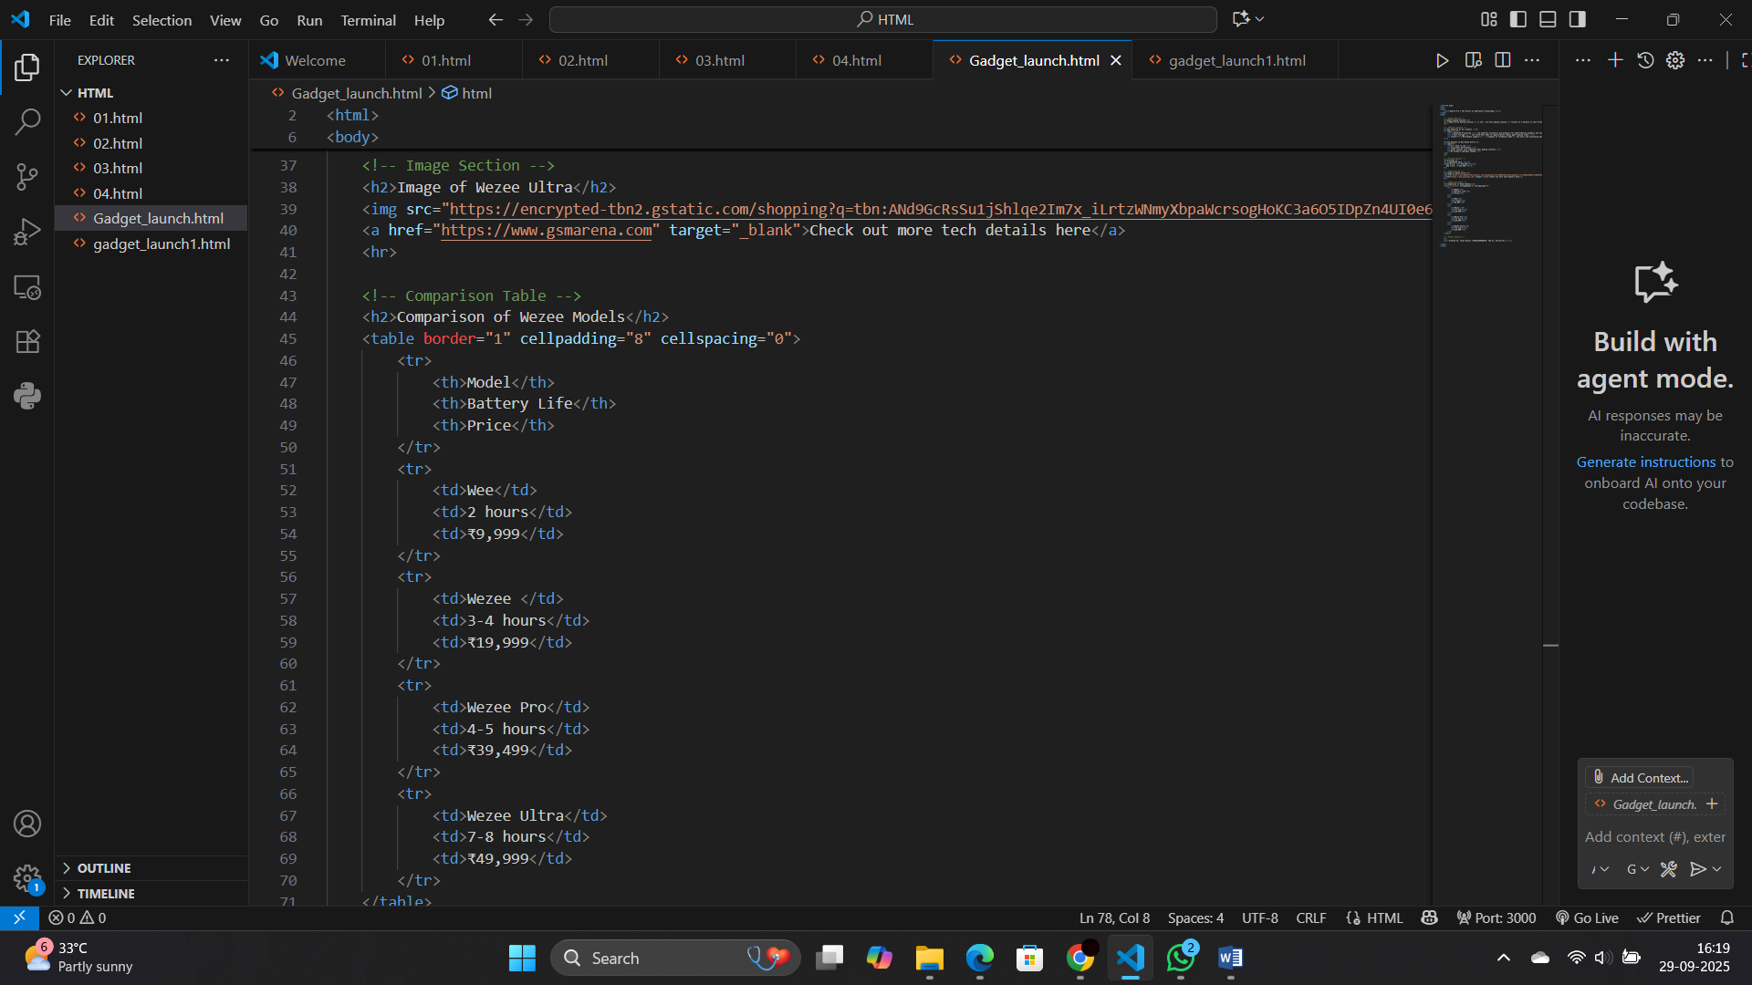

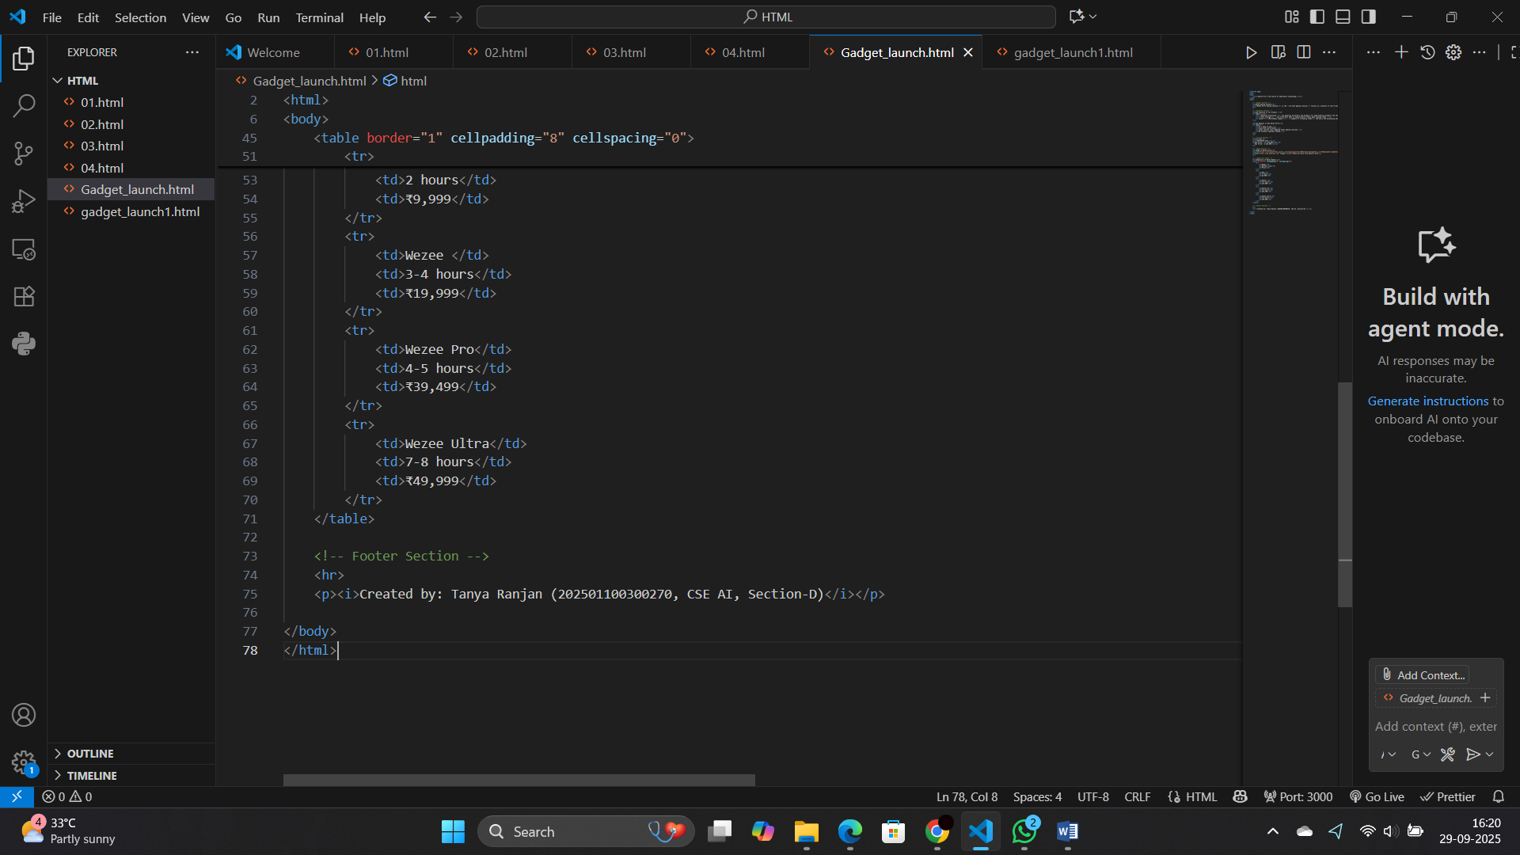

<!DOCTYPE html>

<html>

<head>

    <title>SmartX Pro – The Future of Smartwatch Technology</title>

</head>

<body>

    <!-- Header Section -->

    <h1>Wezee Gaming Console</h1>

    <p><b>WeZee Ultra Gaming Console</b> is the <i>hi-tech gaming console</i> focuses on a balance of user-friendly experience, performance, and affordability.</p>

    <hr>

    <!-- Features Section -->

    <h2>Key Features of our product :</h2>

    <ul type="circle">

        <li><u>Advanced Processing </u>: use powerful processors and graphics for high-fidelity graphics and smooth gameplay. </li>

        <li><u>Fast storage</u> :  use ultra-fast SSDs to significantly reduce game loading times. </li>

        <li value="5"><u>Multimedia support</u> : <i>capable of streaming video</i> and music and displaying photos. </li>

    </ul>

    <h3>Top Reasons to Buy Wezee Ultra</h3>

    <ol type="A">

        <li>It's easy to use.</li>

        <li>Consistent performance.</li>

        <li>Lower initial cost compared other gaming consoles.</li>

        <li>No hardware upgrades needed.</li>

    </ol>

    <hr>

    <!-- Pricing Section -->

    <h2>Pricing</h2>

    <p><b>EXCLUSIVE SALE </b></p>

    <p>Old Price: <del>₹49,999</del><br>

       New Price: <b>₹42,999</b></p>

    <hr>

    <!-- Image Section -->

    <h2>Image of Wezee Ultra</h2>

    <img src="https://encrypted-tbn2.gstatic.com/shopping?q=tbn:ANd9GcRsSu1jShlqe2Im7x_iLrtzWNmyXbpaWcrsogHoKC3a6O5IDpZn4UI0e6QGqJiqv9zNg-p2isZrZdlc2q2NwlzV9Yk8pq1STt_PdbHKvWksUt1ORJ6h0UxoyA" alt="Wezee Ultra Gaming Console" width="300" height="250"><br>

    <a href="https://www.gsmarena.com" target="_blank">Check out more tech details here</a>

    <hr>

    <!-- Comparison Table -->

    <h2>Comparison of Wezee Models</h2>

    <table border="1" cellpadding="8" cellspacing="0">

        <tr>

            <th>Model</th>

            <th>Battery Life</th>

            <th>Price</th>

        </tr>

        <tr>

            <td>Wee</td>

            <td>2 hours</td>

            <td>₹9,999</td>

        </tr>

        <tr>

            <td>Wezee </td>

            <td>3-4 hours</td>

            <td>₹19,999</td>

        </tr>

        <tr>

            <td>Wezee Pro</td>

            <td>4-5 hours</td>

            <td>₹39,499</td>

        </tr>

        <tr>

            <td>Wezee Ultra</td>

            <td>7-8 hours</td>

            <td>₹49,999</td>

        </tr>

    </table>

    <!-- Footer Section -->

    <hr>

    <p><i>Created by: Tanya Ranjan (202501100300270, CSE AI, Section-D)</i></p>

</body>

</html>

**OUTPUT :**

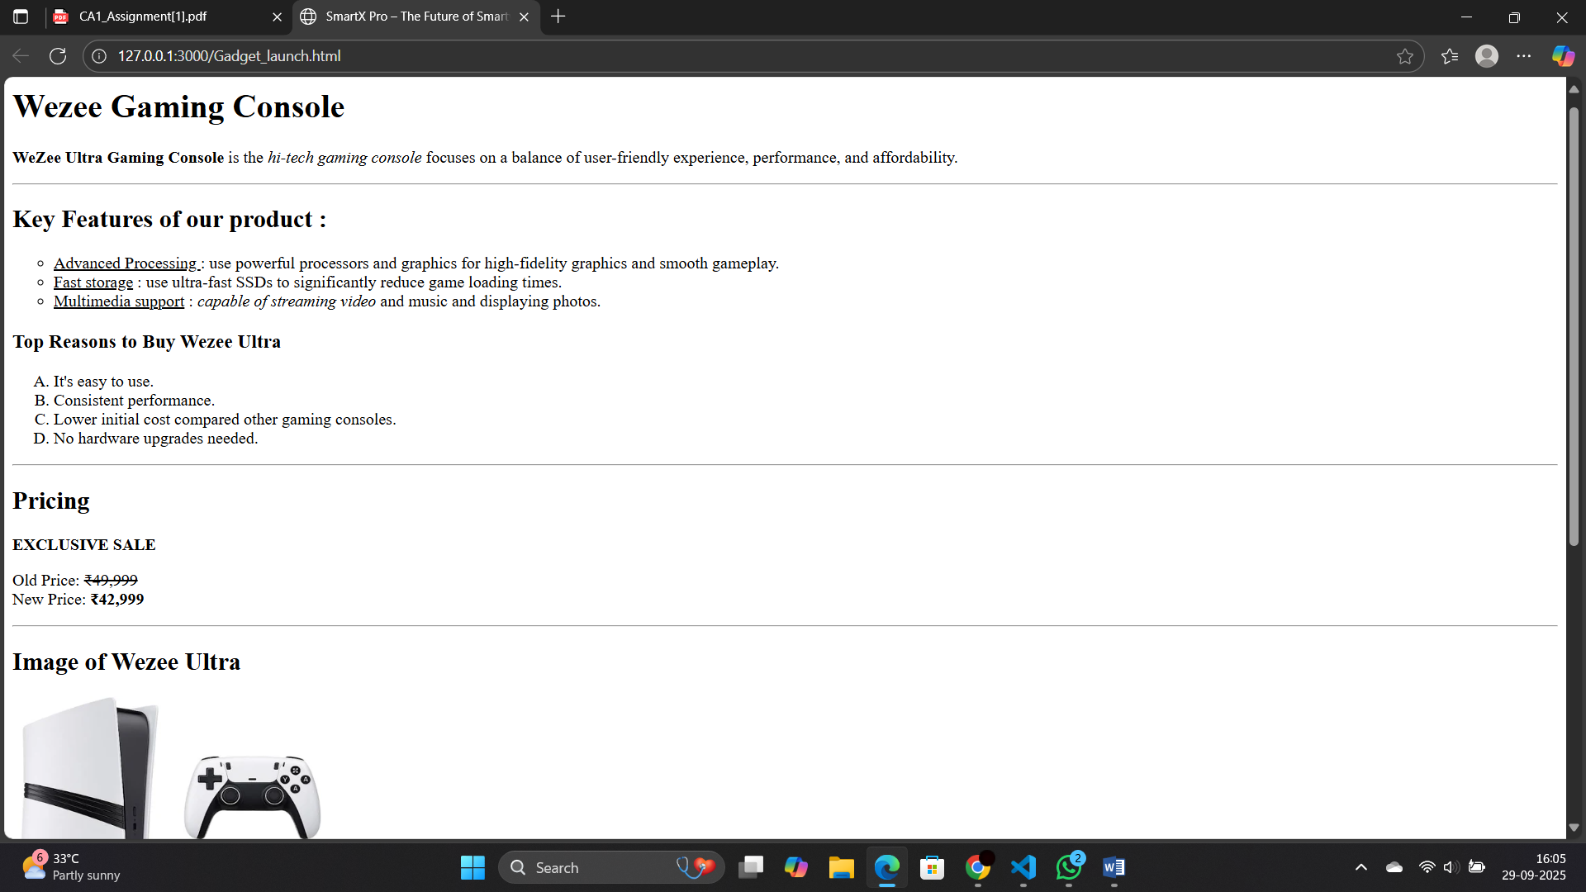

2.

